How to structure your Facebook Ads Account
Last Updated / Reviewed: October 1st, 2021
Execution Time: ~30 min - 2h

Goal: To design a complete blueprint of how your Facebook Ad Account will look like.

Ideal Outcome: You have a blueprint ready to implement on Facebook Ads Manager.

Prerequisites or requirements: If you haven’t set up your first campaign in that account yet, you should already have identified which business goals you want to achieve with Facebook Ads, which campaign objectives are suitable for you, and have a general idea of the audiences you’ll be targeting and which ads you’ll be showing them.

Why this is important: To scale and optimize your Facebook Ads campaigns you need to have a proper structure in place. If your account is disorganized, reporting and optimizing it will be a challenge, your teammates will not understand it and your campaign’s performance will suffer.

Where this is done: A piece of paper is fine. But we have provided you with both a visual template if you want to impress your clients or teammates, or a spreadsheet so you can update it in the future.

When this is done: Every time you’re starting a new Facebook Ads campaign. Or periodically (every 3 months) to make sure you’re following the structure.

Who does this: The person responsible for CRO or Paid Advertising.

Environment Setup

- Open and make a copy of the Facebook Ads Structure template: Click here

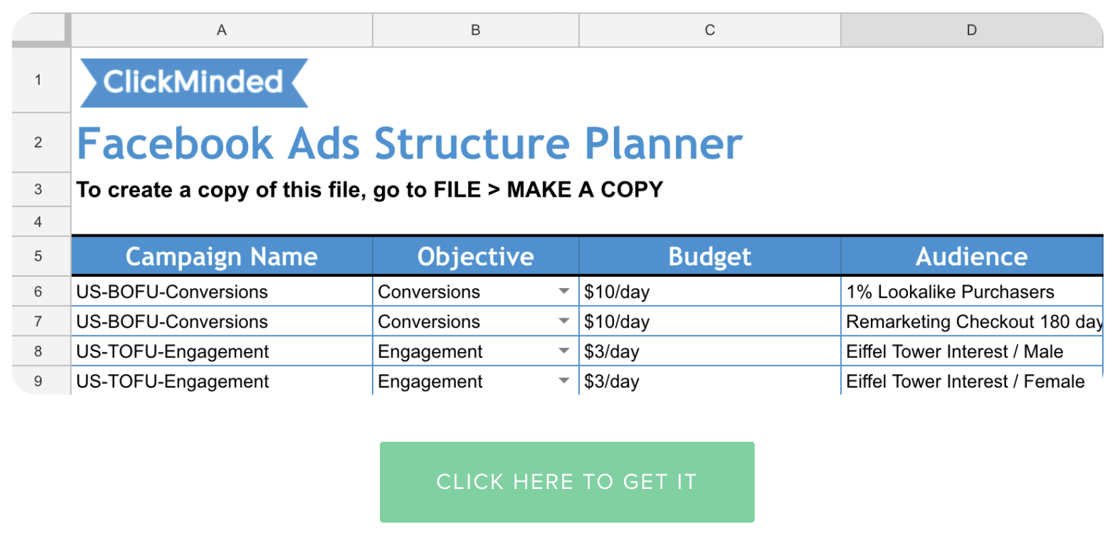
- (Optional) If you want to better convey your new structure to clients, your teammates, or employees, open, copy, and edit the following template:

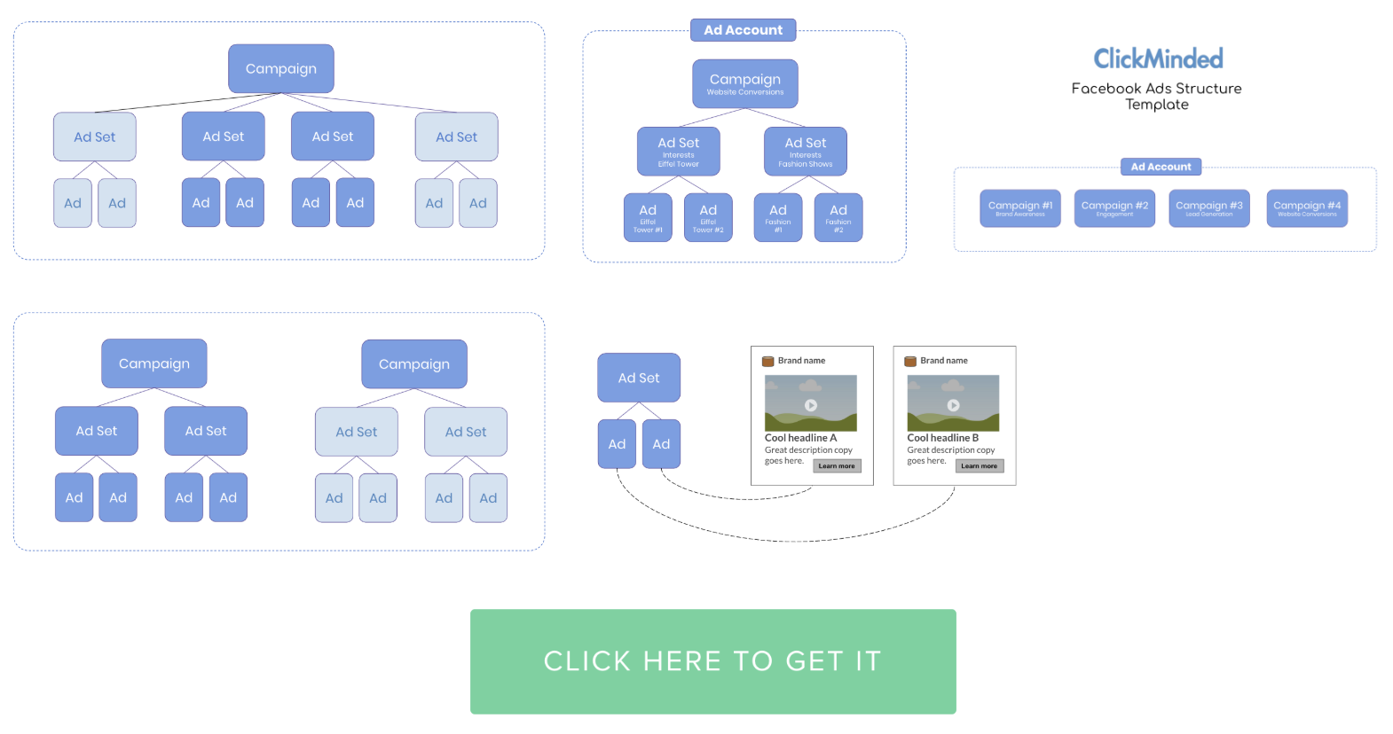

- (Optional) When you’re just getting started, pencil and paperwork just fine to draft your rough structure.

- Move on to the next chapter.

Design your structure
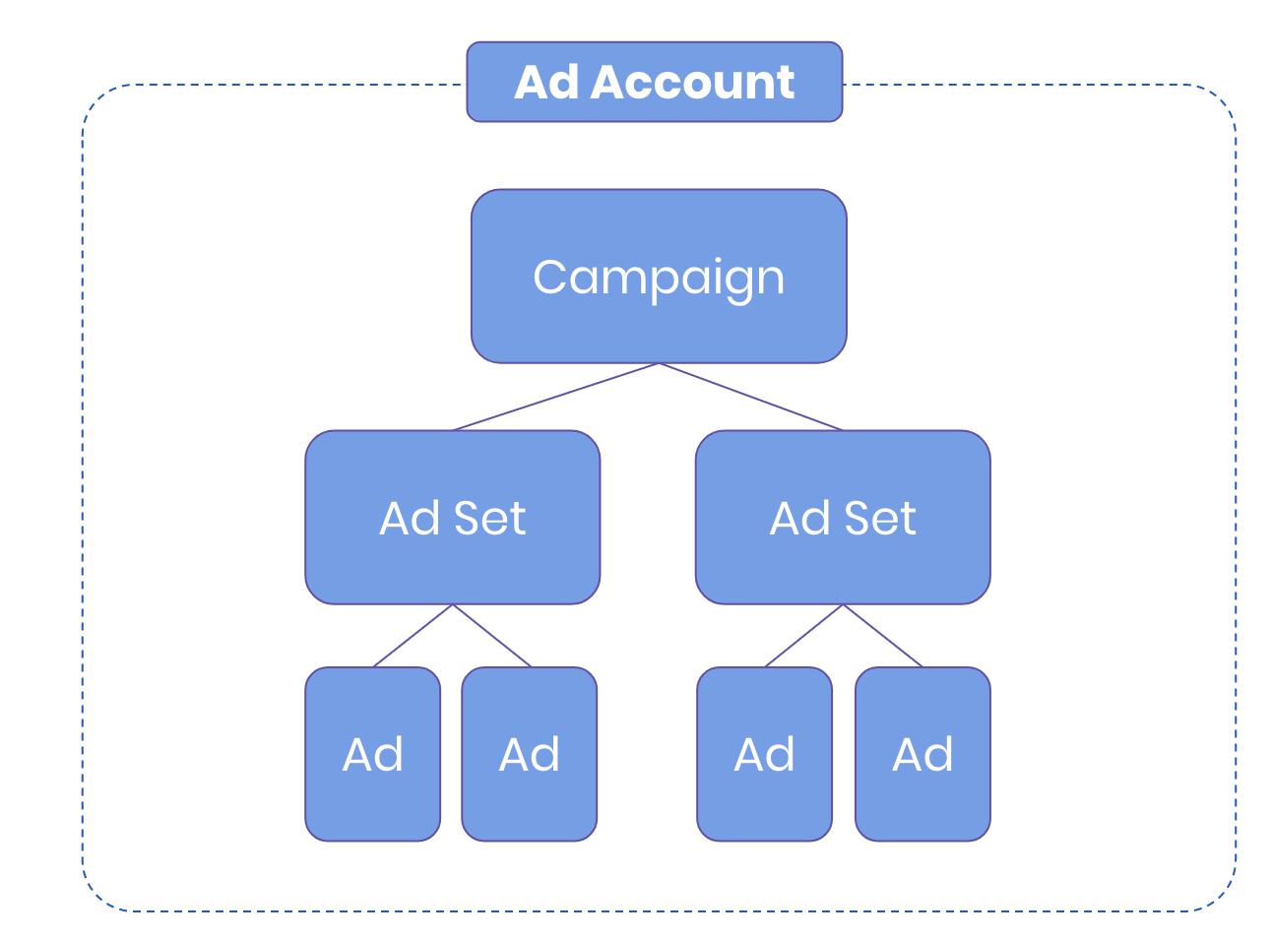

Go through the following questions while updating your templates or draft, to reflect your decisions.

Account level
- Are you an agency/freelancer working on Facebook Ad campaigns for your clients?
  - If yes -
- Use your client’s Facebook Ad Account, do not create his campaigns inside your (or the agency’s) Facebook Ad Account.

Ask your client to give you access to their Ad Account by sending them these instructions.

- Move on to the next question.

  - If not - Move on to the next question.

- Does the business that you’re creating campaigns for own multiple distinct brands (e.g. a Jewelry Brand on www.parisian-handmade-jewelry.com and a Car Accessories Brand on www.joes-auto-garage.com)?

  - If yes - Create an Ad Account for each from inside Business Manager.

Remember: There is a 5 Ad Account limit per Business Manager, depending on ad spend you might be able to request additional accounts if needed. If you’re just starting, the number of Ad Accounts available to you might be limited.

  - If not - Keep all your campaigns inside a single account.

Campaign level
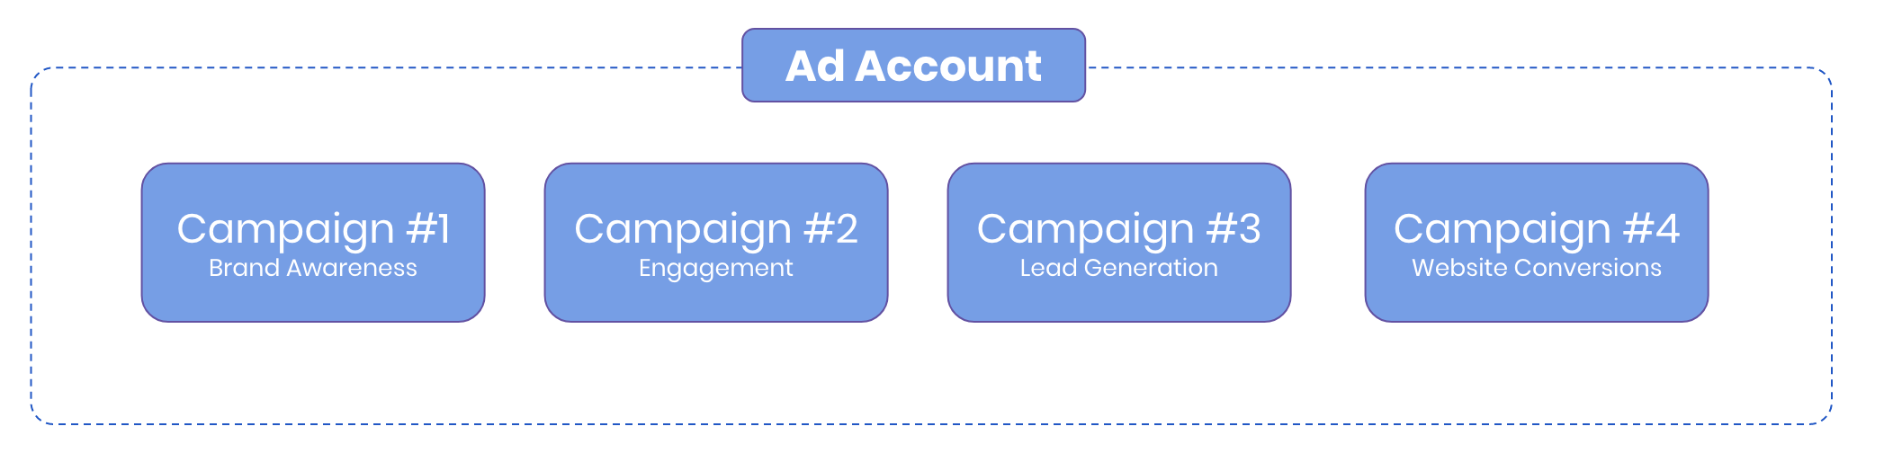
- Create at least one campaign for each business objective.
Note: If you don’t know which Facebook Ad campaign objective to pick, click here.

E.g:
Campaign #1 - Lead Generation
Campaign #2 - Website Conversions - Sales

  - (Optional) If you have more than 10 Ad Sets with significantly different audiences, create a new campaign for them:
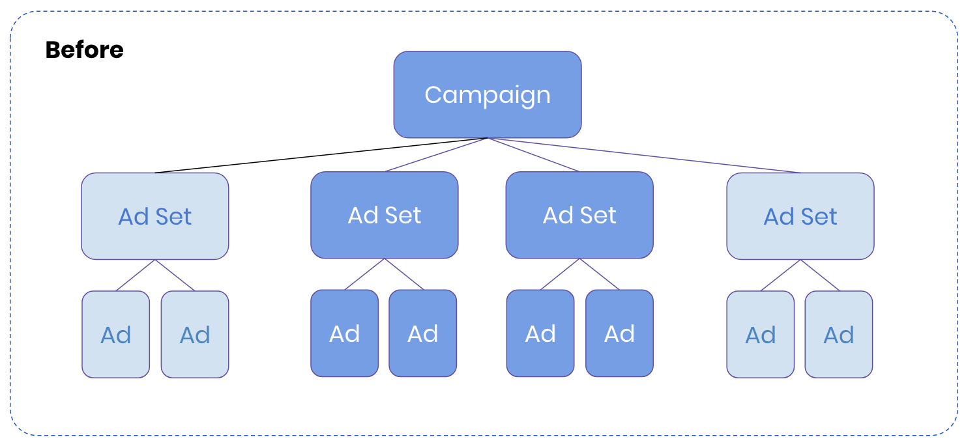

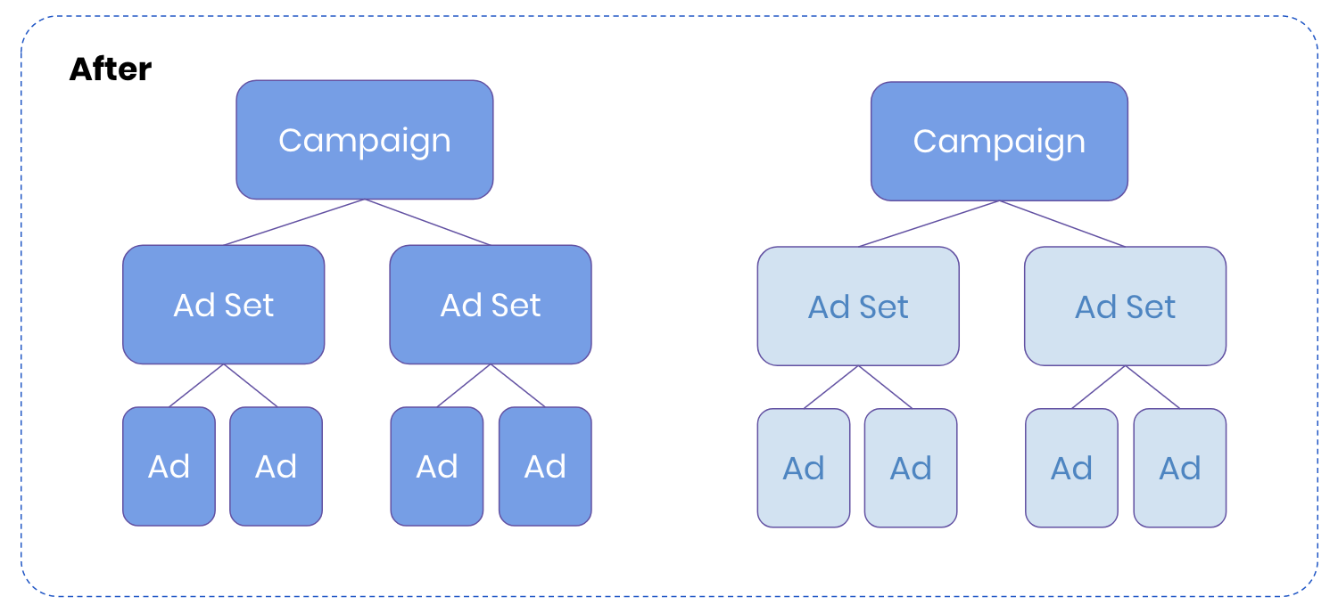
E.g:
Campaign #1 - French - Lead Generation
Campaign #2 - English - Lead Generation

Note: This step is optional but recommended, doing it allows you to more easily analyze these different groups, and gives you easier control over those Ad Sets as a whole allowing you to define budget caps for them all at once, pause or resume all of them at the campaign level, or enable “Campaign Budget Optimization” for those Ad Sets only.

Ad Set level
- Split up different audience targeting groups into different Ad Sets based on:

  - Do you want to serve a specific audience a specific Ad? If so create a specific Ad Set for each.
    - E.g: “If the user is in France I want my Ad to feature the Eiffel tower”
E.g Ad Set:
Ad Set #1 - France - Interest #1 (Eiffel Tower Ads)
Ad Set #2 - United States - Interest #1 - (Other Ads)

  - Do you want to be able to understand which Interest / Demographic / Custom Audience / Lookalike Audience converts better by seeing a breakdown of each? If so create a specific Ad Set for each.

    - E.g: “I wonder which audience is better: ‘Eiffel Tower’ or ‘Gustave Eiffel’”
E.g Ad Set:
Ad Set #1 - Eiffel Tower
Ad Set #2 - Gustave Eiffel

Exception: Age & Gender, Country & Region, Platform, Placement, and Device can be analyzed using Facebook Manager’s default breakdown filter. There is no need to separate Ad Sets based on these properties for reporting purposes.

Keep in mind: If you selected a ‘Conversion’ objective, you should make sure you have enough budget allocated to each Ad Set in order to achieve the 50 conversions / week required for your Ads to complete the ‘Learning Phase’. (assuming the “7 day click / 1 day view”, conversion window)
If not, the benefits of splitting your Ad Set might be offset by the fact that their performance might not be optimal.

Ad level
- Add the ads that you want to be displayed to that specific audience (defined at the Ad Set level).
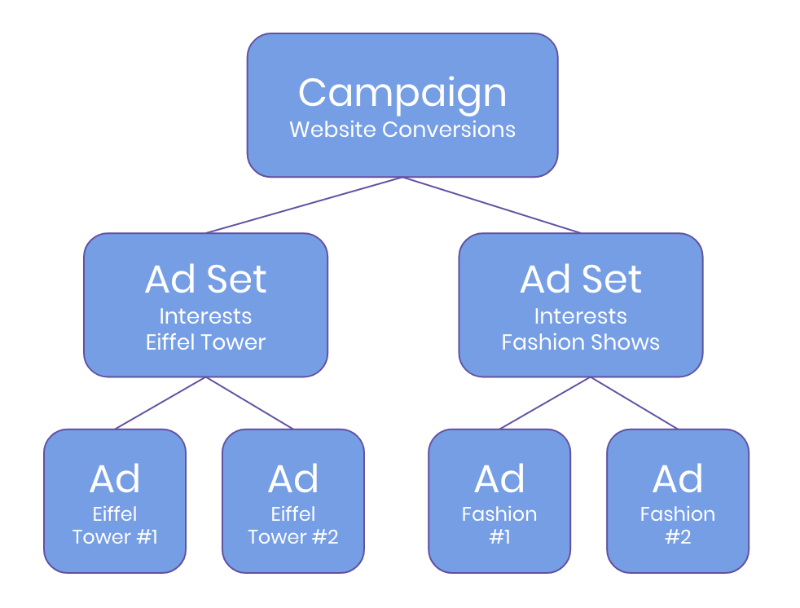
- (Optional but recommended) If you want to test different ads, add multiple ads to your Ad Sets.

  - Note: Test one hypothesis at a time with each ad, this way you will know what is it that makes that Ad perform better than the other.

    - E.g: If you sell Parisian handbags and you’re wondering what makes people buy—if it’s the price or the fact that they are handmade. You could try:
      - Headline #A - “A $499 Parisian handbag for $59 - Check it out”
      - Headline #B - “Handmade Parisian handbag built with love <3 - Check it out”
      - Everything else (Image, Description, News Feed Description, etc) would stay the same

This way, if Headline #A performs better, you can try starting from the fact that they are price sensitive and test something else on your next Ad (e.g: your image) while keeping all the other elements constant.

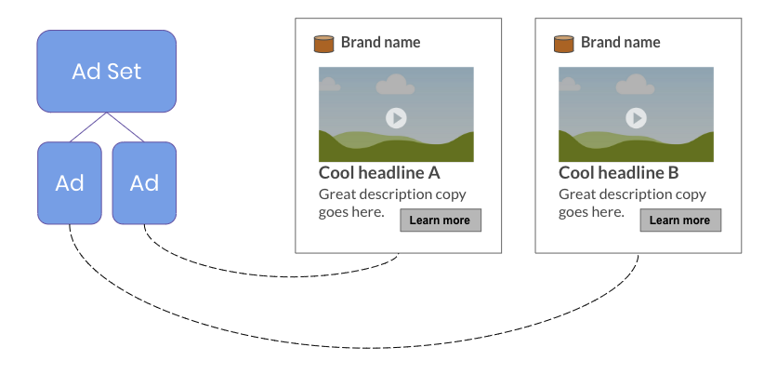

That’s it! Keep iterating through this SOP until you find the perfect structure for you, refer back to it frequently to make sure you stick to it.

